Physics Lab #9: Refraction and Lenses
Charlie Coleman
Lab Partners: Alex Bielewicz, Tracey Jaron
2016 November 08

Abstract: The objective of this lab was to observe and understand the properties of light rays passing between mediums and passing through lenses. The angle of light, measured with respect to the normal line of the surface, changes as the light passes from one medium to another. This angle change is dependent on the indeces of refraction for both mediums. An index of refraction is defined as the speed of light in a vaccuum versus the speed of light in the medium, or c/v. When rays of light leave an object, pass through a lens, and converge at the same point, it creates an image. The lab was a success, as each part had two values to compare, and in each part the values were close to one another. There was no defined range for each part, so the only way to test success is to compare found values.

Theory: When light makes a transition of traveling in one medium to another, part of the energy passes through into the second medium and part of the energy is reflected backwards. The direction of the light is changed in both scenarios. The first scenario is called refraction. The second scenario is called reflection. The angle of the light at the point of transition is measured with respect to the normal line of the surface of the second medium. The angle of the light after the reflection or refraction is also measured with respect to this angle.
Refraction changes the angle of the light ray as it passes into the second medium. The change is defined by the index of refraction of both mediums. An index of refraction is the speed of light in the medium compares to the speed of light in a vaccuum, n=c/v where v is the speed of light in the medium. The change in angle is found using Snell's law, , where n is the index of refraction and theta is the angle.
When light comes off an object and passes through a lens, an image is formed wherever the light rays converge. There are two types of images, real and virtual. Real images are formed when the light rays actually converge at a point. Virtual images are formed when the rays appear to converge but in reality, do not. The difference between a real and a virtual image depends on where the object is and the curvature of the lens. The magnification of a lens is described as where h' is the image distance, h is the object distance, s' is the image height, and s is the object height. If the magnification is negative, the image will be inverted with respect to the object.

Objective: The objective of this lab was to understand the properties of rays when encountering objects and to study the production of images using lenses.

Procedure: In part one, the cylindrical lens should be setup on the rotating disk, with a single beam of light entering and exiting the lens at 90 degrees. Then, the lens is to be rotated with the disc at 10 degree increments and the resultant beam angle is to be recorded. This is to be repeated with the lens facing the opposite direction.
For part two, the light source is setup on one side of a convex lens with a screen on the other side for the image to be projected on. The object is illuminated, and the object and image distance and height are measured. This was repeated for 2 different lenses.
Parts 3 and 4 were qualitative. A telescope and magnifying glass were to be constructed as shown in the setup, and the images produced were examined.

Setup:
Part one:
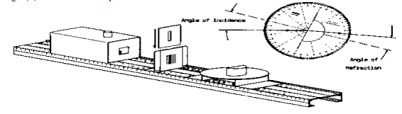
Part three:
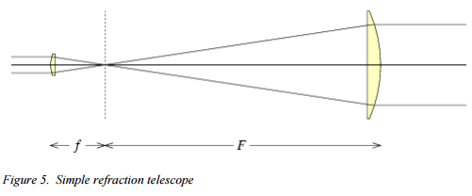
Part four:
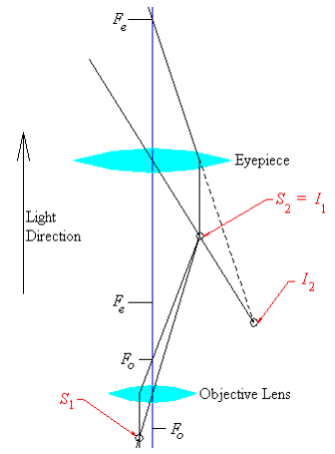

Data:
Part one:
Air to Plastic

Plastic to Air

Total internal reflection: 42.5 degrees
Part two:

Calculations:
Part one:
sin(θ):
n:
Part two:
Magnification:

Qualitative Error Analysis: One error in this lab was focusing the image in part two. It was difficult to tell if the image was in focus perfectly, and a small change in the distance could mean a large change in the calculated magnification. Another error for this lab was the difficulty reading the angle in part one. The beam of light was not infinitely thin, so it was difficult to read the angle, and the beam seemed to expand or split apart at some points.

Quantitative Error Analysis:
Part one:
Percent difference: 2.22447%
Part two:
200mm lens percent diff: 8.917%
100mm lens percent diff: 15.310%

Results:
Part one:
Air to plastic n: 1.500
Plastic to air n: 1.467
n from Lab 8: 1.4
Part two:
200mm lens:
di/do: 1.640
hi/ho: 1.500
100mm lens:
di/do: 2.876
hi/ho: 2.467

Conclusion: In this lab, the behavior of light passing through mediums and lenses was studied. The lab was a success as the each part of the experiment had two values that were meant to be the same, and in each one, the values were close to one another. No definitive value was given as an error range, so the lab can be treated as a success. The values measured in part one were also similar to the value found in the previous lab for the index of refraction for fiber optic cables. The difference between the values could be attributed to the difficulty in measuring angles in part one due to poor accuracy and strange behavior of light. In part two, the differences could be attributed to the difficulty in accurately focusing the image on the screen.

